CASE STUDY REPORT

Group No.: Group 14

Student Names: Neel Lele, Ryan Machado, Shoubhik Roy

Executive Summary:

I. Background ​and Introduction:
​
The project is about forecasting the demand of a product in a Manufacturing firm with footprints globally. The selection of the product was based on the popularity i.e. maximum demand and maximum records of historical demand data. Thus, dataset contains historical product demand of about 2000 products. The company provides multiple products divided into many categories. There are four central warehouses to ship products within the region it is responsible for. Since the products are manufactured in different locations all over the world, it normally takes more than one month to ship products via ocean to different central warehouses.

Origin​ ​of​ ​Data:

The data was taken from www.kaggle.com.
The data comprises of 33 categories and 2160 products and 4 warehouses. The dataset was created in 2012 and it comprises data for 5 years from 2012-2016.

Problem Statement:

To forecast the monthly demand for the highest demand product with reasonable accuracy for month after next so it would be beneficial to the company’s supply chain in order to ensure optimum inventory levels in the warehouse and reduce overhead costs.

Goal of The Study:

Our aim is forecasting the demand of the next month of worldwide orders for the product that has the maximum demand and minimizing the mean forecasting error. This is to ensure the warehouses are stocked with optimum level of inventory for any future distribution purposes. It’ll also help in reducing lead times and unnecessary overhead costs thereby contributing to the overall development of the supply chain.

The Possible Solution:

Using statistical and forecasting methods available in R to meet our goal. We would also need to train our prediction model to ensure accurate predictions in the near future.

II. Data Exploration and Visualization
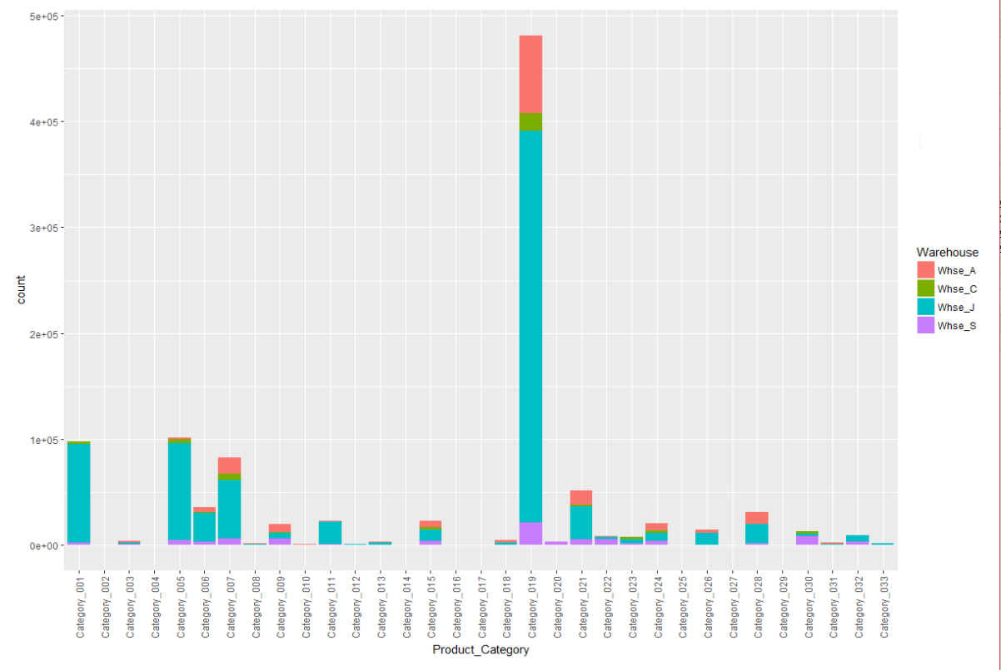
First, we plot the category wise demand according to warehouse. We see that products in category 19 have maximum demand.

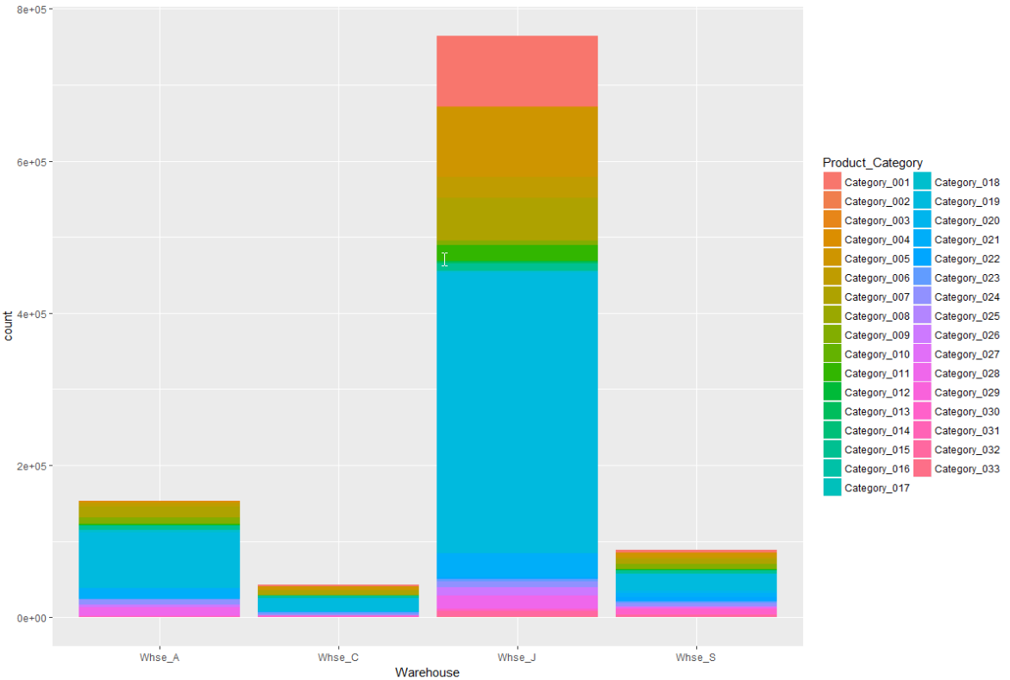
We zero in on product_1359 for our analysis as it was present in category 19 and we had maximum demand records of the same.

Data Cleaning: We clean the data by omitting missing values.
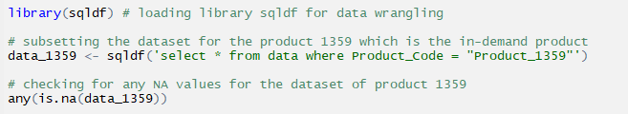

III. Data Preparation and Preprocessing
Lubridating the data, converting the date into the desired format.

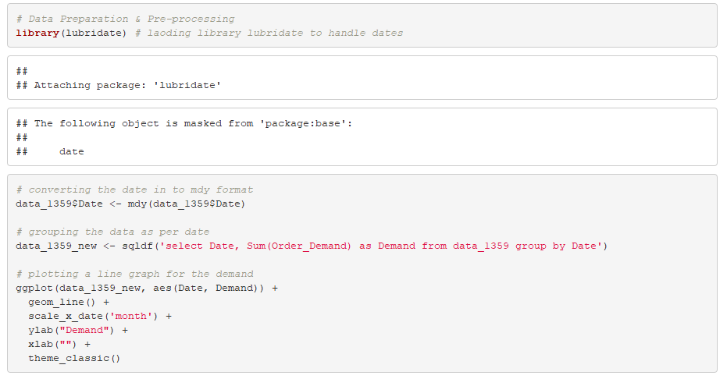

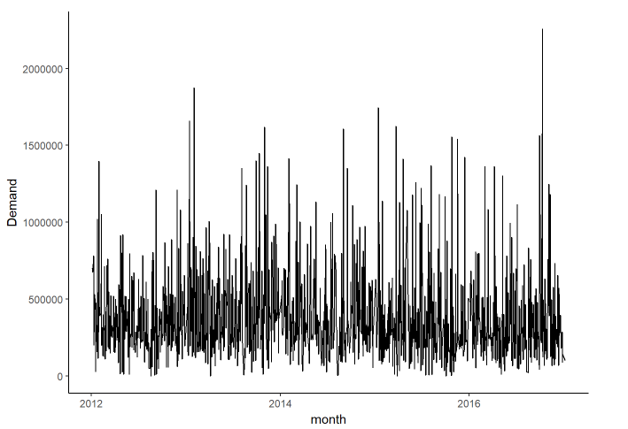

IV. Data Mining Techniques and Implementation
Converting the data to time series.
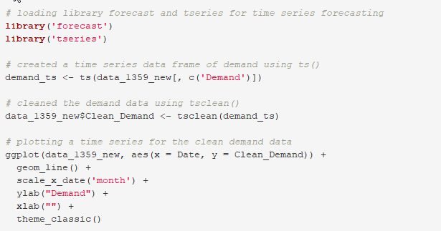

Using the moving average technique to smoothen the spikes in the data
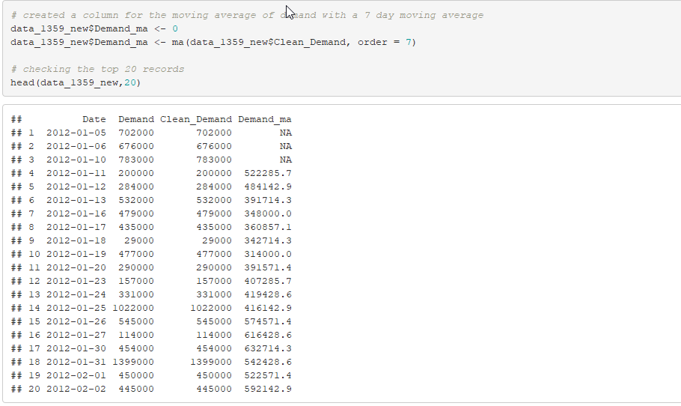

Plotting the moving average values against the original demand data set.
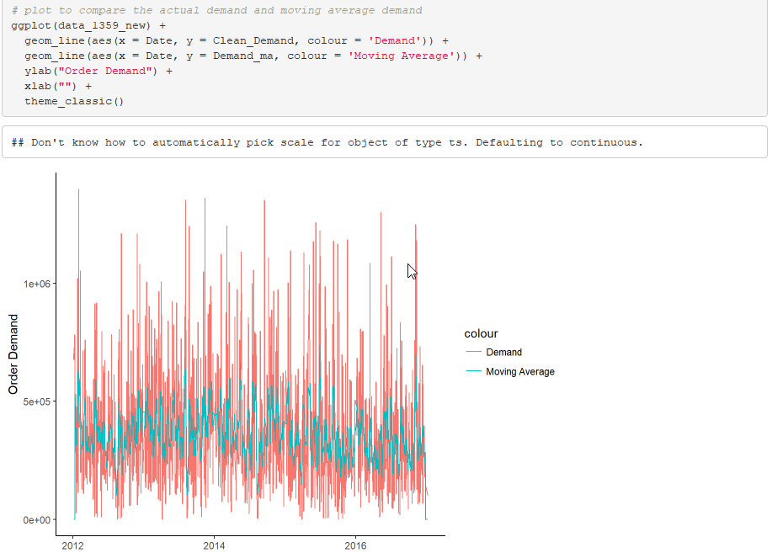

Splitting the data into training and validation set.
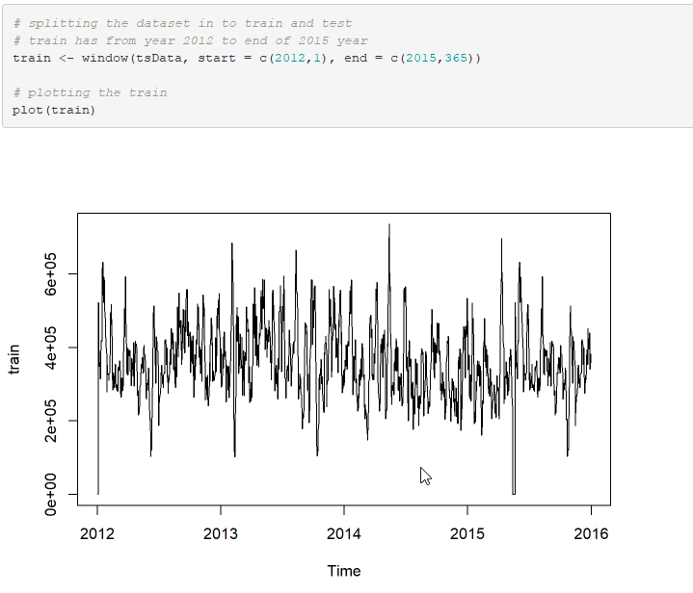

Creating the ARIMA model using the training data and summarizing the errors

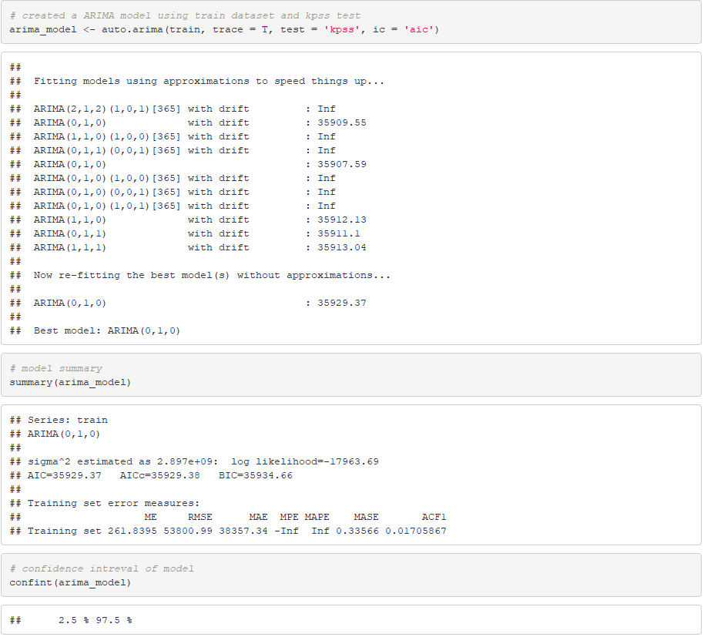

We used the AIC criterion because it gave better fitting model compared to the BIC (Bayesian information criterion).

Comparing the ARIMA training data model with the validation dataset values.
.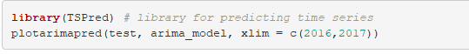
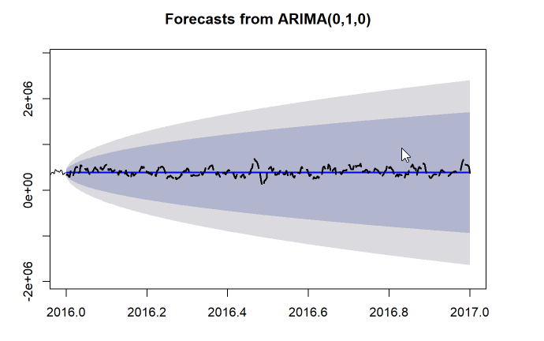
The dotted line indicates the actual values of the demand of the validation set while the blue line denotes the predicted forecasted values using the test data.

Printing the forecasted values under the 80% and 95% confidence intervals.
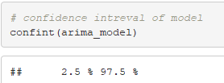

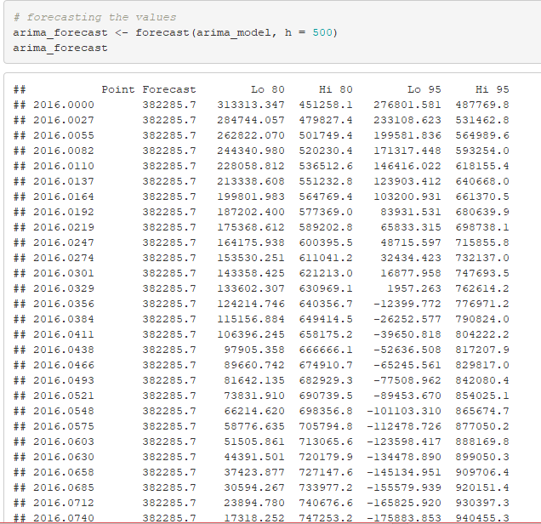

Plotting and printing future demand data after fitting the model.
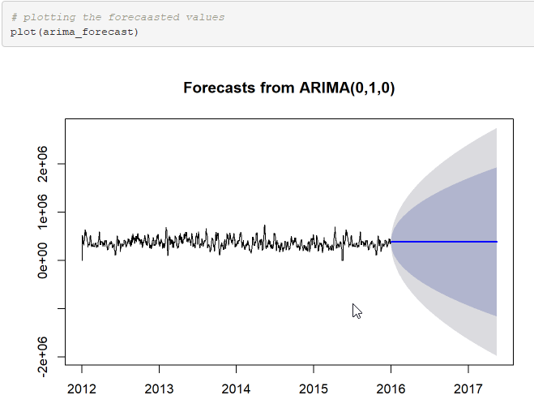
Forecasting future demand (getting the values) under the 80% and 95% confidence interval.
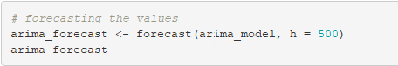

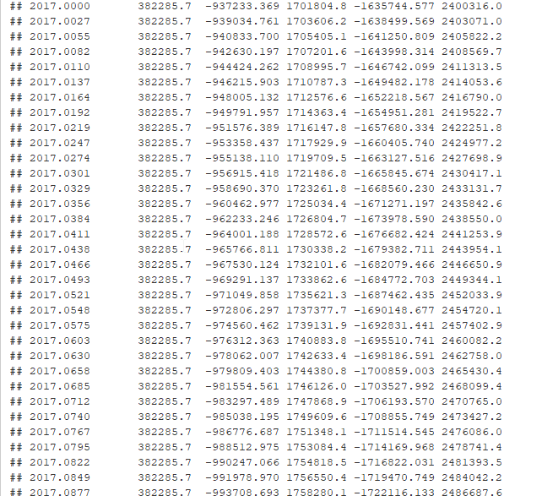

V. Performance Evaluation
We conduct residual diagnostics on the model to evaluate its performance.
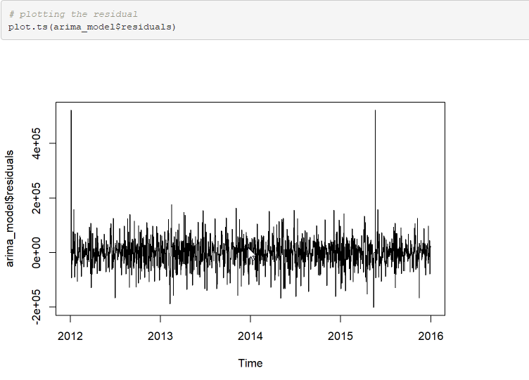
As we can see in the graph the residuals or error revolve around the mean of 0 with an exception of a few spikes due to white noise.

Running other performance evaluation tests like the Ljung-Box and Jarque Bera Test.

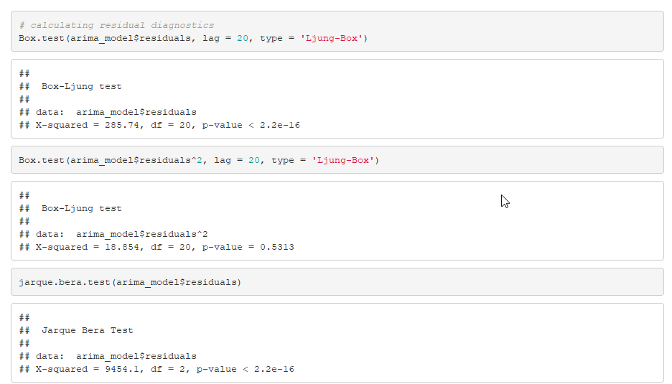
A significantly low p-value in both the tests suggests that the model is a good fit.

VI. Discussion and Recommendation

Overall the ARIMA model is an effective way of forecasting future demand given historical data is provided. The approach would be to plot the data as a time series and use the auto arima function in the forecast library to enable R to automatically decide the best fit.

Advantages: Advantages of the auto arima function is that RStudio itself decides the 3 order parameters i.e. AR (p), I(d), MA(q) which make forecasting very easy for the user.

Disadvantages: The arima model faces difficulty when the data has a particular trend or seasonality. When we consider real world datasets all of them have some degree of seasonality to them.

Solution: The solution to the seasonality and trend problem is that we deseasonalize and stationarize the data thereby removing any kind of trend before using the ARIMA modelling technique.

Potential improvement: Potential improvements in the arima model would be to overcome its only disadvantage of seasonal data. It could improve by understanding the trend and volatility of the data, deduce meaningful patterns and produce accurate forecasts without having the data deseasonalized or cleaned.

VII. Summary
The objective of our project was to help and improve the supply chain of a manufacturing company by forecasting the demand of a particular product that was very popular among its customers as indicated by its high demand records.
We managed to achieve our goal using the ARIMA modelling technique and forecasted the demand for about a month into the future under 80% and 95% confidence intervals.
This would help the manufacturing firm plan and process their inventory in advance thereby saving costs and reducing lead times.
We have performed our analysis on the most popular product of the firm, a similar analysis can be done for all 2000 products if and when needed.

Appendix: R Code for use case study
---
title: "Final Project"
author: "Group 14"
date: "June 20, 2018"
output: html_document
---

```{r, warning=F}
# Data Loading
# load the data in to the R Studio using read.csv()
data <- read.csv('Historical Product Demand.csv', header = T, stringsAsFactors = F)

# Data Exploration & Visualization
# checking the structure of the data
str(data)

# checking for any NA values associated with the data
any(is.na(data))

# which column(s) has the NA values
colnames(data)[colSums(is.na(data)) > 0]

library(ggplot2) # loading library ggplot2 for visualization

# plotting the bar plot for product_category across warehouse
ggplot(data, aes(Product_Category))+
geom_bar(stat = "Count", aes(fill = Warehouse)) +
theme(axis.text.x=element_text(angle=90,hjust=1,vjust=0.5))

# plotting the bar plot for warehouse across each product_category
ggplot(data, aes(Warehouse))+
geom_bar(stat = "Count", aes(fill = Product_Category))

# checking the distribution of Order Demand using boxplot
boxplot(summary(data$Order_Demand))

library(sqldf) # loading library sqldf for data wrangling

# subsetting the dataset for the product 1359 which is the in-demand product
data_1359 <- sqldf('select * from data where Product_Code = "Product_1359"')

# checking for any NA values for the dataset of product 1359
any(is.na(data_1359))

# Data Preparation & Pre-processing
library(lubridate) # laoding library lubridate to handle dates

# converting the date in to mdy format
data_1359$Date <- mdy(data_1359$Date)

# grouping the data as per date
data_1359_new <- sqldf('select Date, Sum(Order_Demand) as Demand from data_1359 group by Date')

# plotting a line graph for the demand
ggplot(data_1359_new, aes(Date, Demand)) +
geom_line() +
scale_x_date('month') +
ylab("Demand") +
xlab("") +
theme_classic()

# loading library forecast and tseries for time series forecasting
library('forecast')
library('tseries')

# created a time series data frame of demand using ts()
demand_ts <- ts(data_1359_new[, c('Demand')])

# cleaned the demand data using tsclean()
data_1359_new$Clean_Demand <- tsclean(demand_ts)

# plotting a time series for the clean demand data
ggplot(data_1359_new, aes(x = Date, y = Clean_Demand)) +
geom_line() +
scale_x_date('month') +
ylab("Demand") +
xlab("") +
theme_classic()

# created a column for the moving average of demand with a 7 day moving average
data_1359_new$Demand_ma <- 0
data_1359_new$Demand_ma <- ma(data_1359_new$Clean_Demand, order = 7)

# checking the top 20 records
head(data_1359_new,20)

# function to convert NA values to 0
c20 <- function(x) { x[is.na(x)] <- 0; x }

# applying functuon to the dataset using lapply()
data_1359_new$Demand_ma <- data.frame(lapply(data_1359_new$Demand_ma, c20))

# plot to compare the actual demand and moving average demand
ggplot(data_1359_new) +
geom_line(aes(x = Date, y = Clean_Demand, colour = 'Demand')) +
geom_line(aes(x = Date, y = Demand_ma, colour = 'Moving Average')) +
ylab("Order Demand") +
xlab("") +
theme_classic()

# created the time series data with frequency 365 i.e one year starting from year 2012 till 2017
tsData = ts(data_1359_new[,c(4)], frequency = 365, start = c(2012,1), end = c(2017,1))

# plotting the time series data
plot(tsData)

# checking the dimension of the dataset
dim(as.matrix(tsData))

# splitting the dataset in to train and test
# train has from year 2012 to end of 2015 year
train <- window(tsData, start = c(2012,1), end = c(2015,365))

# plotting the train
plot(train)

# test has from year 2016 to end
test <- window(tsData, start = c(2016,1))

# plotting the test
plot(test)

# created a ARIMA model using train dataset and kpss test
arima_model <- auto.arima(train, trace = T, test = 'kpss', ic = 'aic')

# model summary
summary(arima_model)

# confidence intreval of model
confint(arima_model)

# plotting the residual
plot.ts(arima_model$residuals)

# calculating residual diagnostics
Box.test(arima_model$residuals, lag = 20, type = 'Ljung-Box')
Box.test(arima_model$residuals^2, lag = 20, type = 'Ljung-Box')
jarque.bera.test(arima_model$residuals)

# forecasting the values
arima_forecast <- forecast(arima_model, h = 500)
arima_forecast

# plotting the forecaasted values
plot(arima_forecast)

library(TSPred) # library for predicting time series
plotarimapred(test, arima_model, xlim = c(2016,2017))

# checking the accuracy
accuracy(arima_forecast, test)

